communication inside mines where cellular/mobile networks are unavailable, you can build your own communication network. But RFID is generally not suitable for communication between people over useful distances.
The best technology depends heavily on whether this is an open-pit mine or underground mine, and the required range.

Practical options
Technology | Typical useful range | Data | Works underground? | Suitable for miners?
RFID | cm–10s of m | Very small | Limited | ❌ Mainly identification
LoRa / LoRaWAN | 1–15+ km* | Low data | ✅ Potentially | ⭐⭐⭐⭐⭐
Sub-GHz mesh | 100m–1km/node | Low–medium | ✅ | ⭐⭐⭐⭐⭐
Zigbee/802.15.4 mesh | 50–300m/node | Medium | ✅ | ⭐⭐⭐
Wi-Fi mesh | 50–300m/node | High | ✅ with infrastructure | ⭐⭐⭐⭐
UHF/VHF radio | km | Voice/data | ✅ Depending on mine | ⭐⭐⭐⭐⭐
LTE private network | km | High | ✅ | ⭐⭐⭐⭐⭐
BLE mesh | 10–100m/node | Low | Limited | ⭐⭐
*Very dependent on antenna, frequency, terrain, tunnels, rock, regulations, and node placement.
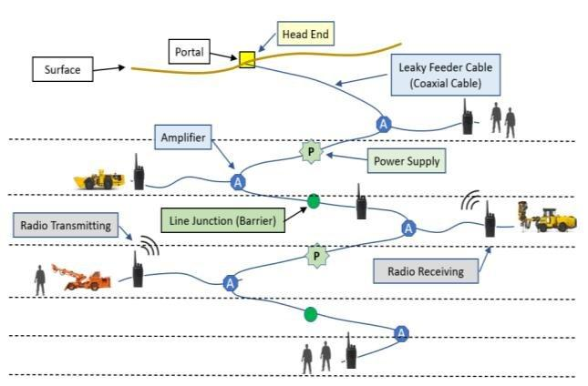
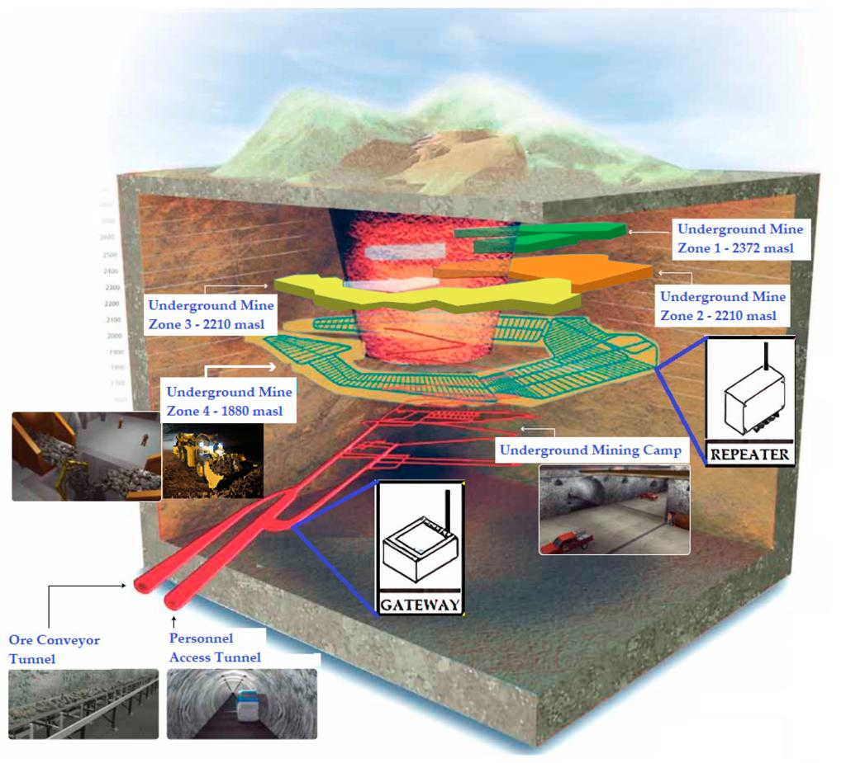
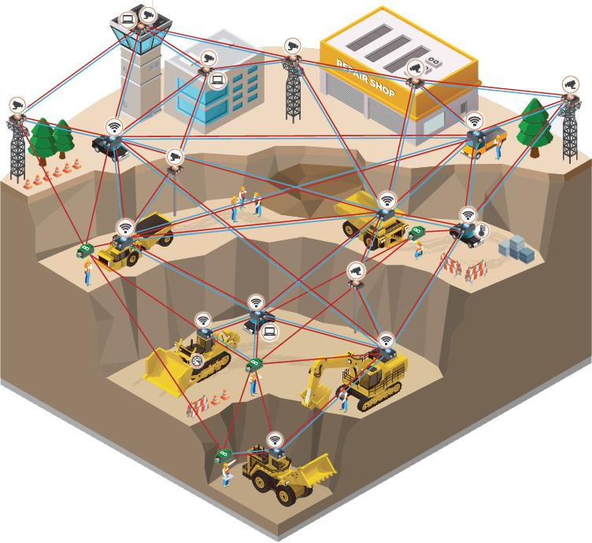
6

What I would recommend
For a low-cost research/project system, I'd look at a LoRa + mesh/repeater architecture rather than RFID.
For example:
SURFACE
┌─────────────────────┐
│ Control Station │
│ Raspberry Pi/PC │
└──────────┬──────────┘
│
LoRa Gateway
│
───────┼───────
│
Underground tunnel
│
[Node/Repeater 1]
│
[Node/Repeater 2]
│
[Node/Repeater 3]
│
[Node/Repeater 4]
/ \
Miner A Miner B
device device
Each miner could carry a small device containing:
- LoRa transceiver
- Microcontroller (ESP32/STM32)
- SOS/emergency button
- Buzzer
- LED/display
- Battery
- Optional microphone/speaker
- Optional gas/temperature sensors
- Optional IMU for movement/fall detection

But there is an important limitation
LoRa is excellent for short text messages, emergency alerts, sensor data and tracking. It is NOT suitable for normal voice conversations.
For example:
Miner A → "HELP – Location 23"
could work very well.
But:
Miner A ↔ Miner B
continuous voice conversation
requires a different architecture/bandwidth.

An interesting solution: Mesh communication
For an underground mine, I would seriously consider a self-forming mesh network.
Imagine nodes installed every 200–500 m:
Surface
│
Gateway
│
▼
┌──────────┐
│ Node #1 │
└────┬─────┘
│
┌────▼─────┐
│ Node #2 │
└────┬─────┘
│
┌────▼─────┐
│ Node #3 │
└────┬─────┘
│
┌────────┴────────┐
▼ ▼
Miner A Miner B
If Node #2 cannot directly reach the surface, it sends the packet through Node #1.
This gives you:
Miner → nearest node → node → node → surface control room
And if one node fails, a properly designed mesh can potentially route through another path.

Even better for a research project
You could combine three functions:

1. Communication
LoRa/Sub-GHz mesh

2. Tracking
Each miner has a unique ID.
Miner 001
Miner 002
Miner 003
...
The system can determine which communication node last heard from the miner.

3. Emergency system
Every miner device has:
SOS button
When pressed:
SOS pressed
↓
Miner device
↓
Nearest mesh node
↓
Gateway
↓
Control room
↓
Alarm + miner ID + last known location
This is considerably more useful than simply building an "offline messaging" system.

Could RFID be incorporated?
Yes—but I would use RFID for identification, not communication.
For example, put RFID tags at:
Mine Entrance
↓
Tunnel A
↓
Tunnel B
↓
Work Area
A miner's wearable device passes an RFID reader.
The system records:
08:32 Miner 014 → Entrance
08:47 Miner 014 → Tunnel A
09:03 Miner 014 → Work Area B
Then LoRa handles actual communication.
So:
RFID = "Who is here?"
LoRa/Mesh = "Send information."

Another technology worth considering: UWB
If your research is particularly interested in accurate underground positioning, look at UWB (Ultra-Wideband).
You can install anchors:
UWB Anchor
●
/ \
/ \
/ \
●─────●───────●
Anchor Miner Anchor
UWB can provide much more precise ranging/positioning than ordinary LoRa.
A potentially strong system would therefore be:
LoRa + UWB + sensors
MINER DEVICE
│
┌──────────┼──────────┐
│ │ │
LoRa UWB Sensors
│ │ │
Communication Location Safety
That could become a very good M.Tech/PhD/research project, especially if you are looking at mining safety.

If voice communication is the main requirement
Then I would not choose RFID or LoRa.
I'd investigate:
UHF/VHF digital radio, private LTE/5G, or leaky-feeder radio systems.
Leaky-feeder systems are particularly interesting in underground mines because a cable installed along the tunnel acts as part of the radio distribution system:
Surface radio
│
│
═════╪══════════════════════
│ Leaky feeder cable
│
├──── Radio ─── Miner
│
├──── Radio ─── Miner
│
└──── Radio ─── Miner
This is a mature approach for underground radio coverage.

My recommendation
If your goal is to design a new, affordable research prototype, I'd start with:
LoRa-based self-healing mesh communication + UWB positioning + emergency/SOS + environmental sensors
rather than RFID.

